1. **Write short note on Cluster Computing.**

Cluster computing defines several computers linked on a network and implemented like an individual entity. Each computer that is linked to the network is known as a node.

Cluster computing provides solutions to solve difficult problems by providing faster computational speed, and enhanced data integrity.

The connected computers implement operations all together thus generating the impression like a single system (virtual device). This procedure is defined as the transparency of the system.

1. **Write short note on utility Computing.**

Utility computing is a service provisioning model where a provider makes computing resources, infrastructure management and technical services available to customers as they need them.

The provider then charges the customer for the amount of services they use rather than a flat-rate fee.

Like other types of on-demand computing -- such as grid computing -- the utility model seeks to maximize efficient resource use, minimize associated costs or both.

1. **Differentiate between parallel and distributed computing.**

**Parallel Computing 🏃💨**

Parallel computing uses multiple processors that are tightly coupled and share a single memory space within a single computer. The goal is to speed up the execution of a single program. Communication between processors is very fast since they access the same memory. It's often used for scientific **simulations and high-performance computing.**

**Distributed Computing 🌐**

Distributed computing uses multiple, independent computers (nodes) that are loosely coupled and connected via a network. Each computer has its own memory, and they communicate by passing messages over the network. The focus is on scalability, fault tolerance, and resource sharing. It's used for large-scale systems like cloud computing and web services.

1. **mention pros and cons of consumption based prising.**

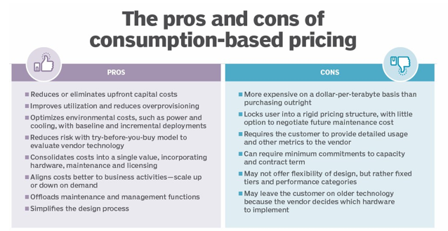

**5. Explain any two cloud service model with example.**

1. **Platform as a Service (PaaS)**

Provides environment for building,testing,and deploying software applications; without focusing on managing underlying infrastructure.

This service provides user a capability to deploy user-created or acquired applications onto the cloud infrastructure.

This application is created using programming languages and tools supported by the cloud service provider Thus, the cloud service provider provides an operating system, hardware, and network where the user installs or develops their own software and applications.

The consumer does not manage or control the underlying cloud infrastructure including network, servers, operating systems, or storage, but has control over the deployed applications and possibly application hosting environment configurations.

2.**Software as a Service (SaaS)**

Users connect to and use cloud-based apps over the internet: for example, Microsoft Office 365, email, and calendars.

This service provides user the capability to use any applications (which are developed by service provider) by executing it on a cloud infrastructure i.e., any pre-made application, along with the required software, operating system, hardware and network, is provided by the service provider.

The applications are accessible from various client devices through Internet via a thin client interface such as a web browser (e.g., web- based email).

1. **Mention challenges and issues in cloud computing**

1 .**Security and Privacy :**

Security and Privacy of information is the biggest challenge to cloud computing.

Security and privacy issues can be overcome by employing encryption, security hardware and security applications.

2.**Reliability and Availability**

It is necessary for cloud systems to be reliable and robust because most of the businesses are now becoming dependent on services provided by third-party.

1. **list recent trends in cloud computing.**

Cloud computing is an evolution of technology over time.

The concept of cloud computing dates to the 1950s when large-scale

mainframes with high-volume processing power became available.

In order to make efficient use of the computing power of mainframes, the practice of time sharing, or resource pooling, evolved.

1. **Explain with diagram cloud architecture.**

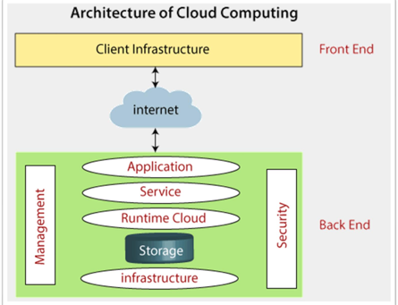

Front End

The front end is used by the client. It contains client-side interfaces and applications that are required to access the cloud computing platforms.

The front end includes web browsers (including Chrome, Firefox, internet explorer, etc.), thin & fat clients, tablets, and mobile devices.

Back End

The back end is used by the service provider.

It manages all the resources that are required to provide cloud computing services.

It includes a huge amount of data storage, security mechanism, virtual machines, deploying models, servers, traffic control mechanisms, etc.

**9. list characteristics of cloud**

1. On-demand self-services

The Cloud computing services does not require any human administrators, users themselves are able to provision, monitor and manage computing resources as needed.

2. Broad network access

The Computing services are generally provided over standard networks and heterogeneous devices.You can access the given service over the internet or private network.

3.Rapid elasticity

The Computing services should have IT resources that are able to scale out and in quickly and on as needed basis.

The services, which are provided, can be rapidly and elastically changed.

It should appear to the user that all services are unlimited and can be purchased in any quantity at anytime from anywhere.

1. **Define cloud computing**

Cloud Computing is the delivery of computing services over the internet, enabling faster innovation, flexible resources and economies of scale.

1. **List different advantages of a virtualization.**

Sharing of resources helps cost reduction

**Isolation**: Virtual machines are isolated from each other as if they are physically separated

**Encapsulation**: Virtual machines encapsulate a complete computing environment

**Hardware Independence**: Virtual machines run independently of underlying hardware

**Portability**: Virtual machines can be migrated between different hosts.